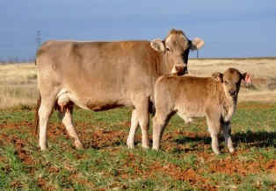 LSU AgCenter Beef Cattle Fact Sheet 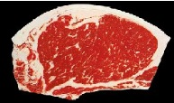
“Administering Injections to Beef Cattle Properly”
Tim G. Page, Ph.D.

First, I know we have a strong Beef Quality Assurance Program in Louisiana and the entire country. We should be proud of that. However, in traveling around the state and working with producers I regularly see producers giving injections in the hindquarter area. This is a big red flag. Injections should never be given in the in the hindquarter of beef cattle. It can create tissue damage and abcesses in some of the best cuts of beef. Nearly all injections (intramuscular and subcutaneous) can be administered in the neck. Some injections producers give to cattle are vaccines, vitamins and minerals, and antibiotics. We need to always do everything we can to minimize residues, injection-site lesions, and side effects.

Do not assume anything when administering injections. Just because you have been using a product in the past, does not mean the label and recommendations for use has not changed. The injection site or dosage may have changed since last year. A product may have been intramuscular (IM) in the past is now subcutaneous (SQ). All SQ injections need to be given in the neck. The loose skin behind the shoulder can also be used for SQ injections. Personally, I have always given vaccines in the left side of the neck and any other injections in the right side of the neck. Why would I do this? By doing this, if a bad reaction or lesion occurs in the neck, I can trace it back to the vaccine or other pharmaceutical (example: antibiotic) that I have used. I fully understand that the real world of processing cattle is not completely sterile and sanitary. That does not mean that we should not do everything we can to give injections into clean and dry areas of the neck. If the injection site is dirty, you are injecting that dirt (bacteria, etc.) into the animal.

The appropriate needle size is also important when administering injections. I recommend that 16 gauge needles be used for mature cattle and 18 gauge needles be used for calves. Vaccine usually can be injected with 18 gauge needles. Some antibiotics are so thick it requires a 16 gauge needle to properly administer it. The length of needle should be considered as well. Most injections can be made with ¾” to 1 ½” needles. I recommend the shortest needle possible to properly administer the injection.

My last recommendation is to keep accurate records of all injections. A record of all cattle treatments and injections will make for a better total health program and they will make you a better manager of your operation. 9/17

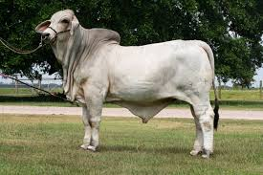

The LSU Agricultural Center is a statewide campus of the LSU System and provides equal opportunities in programs and employment.

